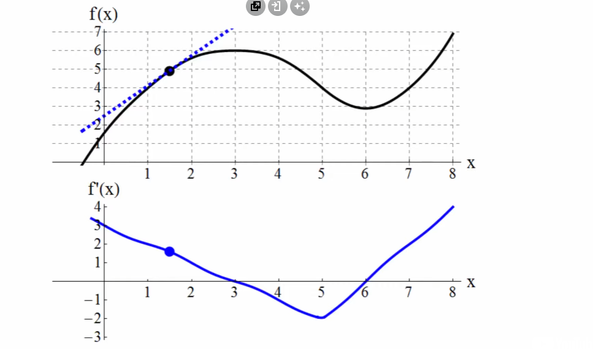

* One tangent line corresponds to 1 point in our derivative graph
* The value of the point in our derivative graph is the slope of the tangent line

